COSC 4333: Distributed Systems
Assignment 5
Due: 10:00am, Nov. 8, 2024 (Friday)

Name: __Andrew Kalathra____

LUID: _______L20498001_____

Date: _______11/08/2024_____

(25 points)1. Please use the following example to explain how to measure inconsistency:
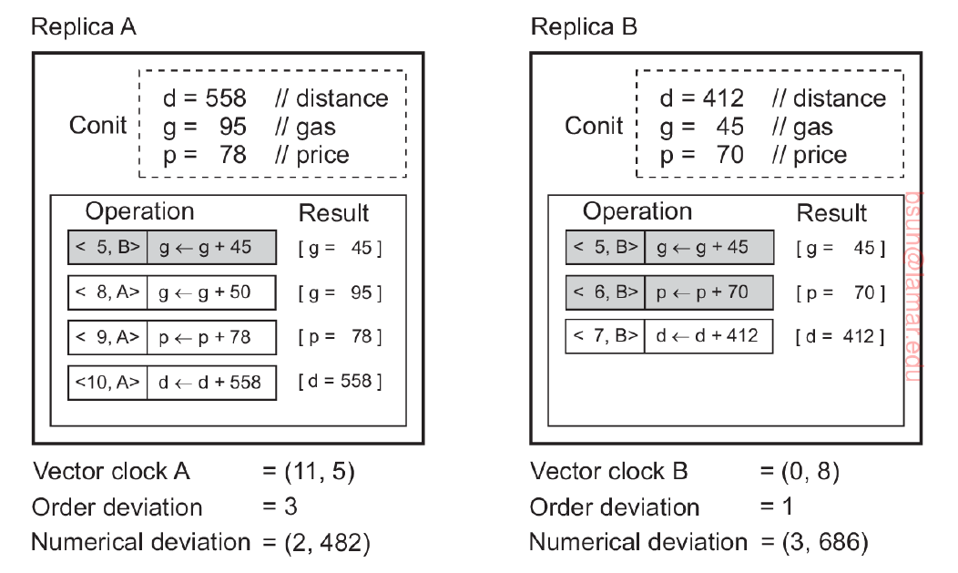
- For Replica A
  - Time 5: Replica B has an operation, increasing gas by 45: g = 45
  - Time 8: Replica A has an operation, increasing gas by 50: g = 95
  - Time 9: Replica A has an operation, increasing price by 78: p = 78
  - Time 10: Replica A has an operation, increasing distance by 558: d = 558
- For Replica B
  - Time 5: Replica B has an operation, increasing gas by 45: g = 45
  - Time 6: Replica B has an operation, increasing price by 70: p = 70
  - Time 7: Replica B has an operation, increasing distance by 412: d = 412
- As we can see, there is a major inconsistency between these two replicas. These inconsistencies can be measured and summarized using their final vector clocks, order deviation, and numerical deviation.
  - Vector Clocks
    - Replica A ends with a vector clock of <11, 5>, denoting that Replica A’s last operation is at time 11, and Replica B’s last operation was at time 5. As we can see above, this is already inconsistent due to multiple operations of B past time 5.
    - Replica B ends with a vector clock of <0, 8>, denoting that Replica A’s last operation is at time 0, and Replica B’s last operation was at time 8. As we can see above, this is already inconsistent due to multiple operations of A past time 0.
  - Order Deviation – how many tentative operations are present
    - Replica A has 3 tentative operations as shown by the white boxes (as opposed to the 1 grey box). This means these changes are not fully committed.
    - Replica B has 1 tentative operation as shown by the white boxes (as opposed to the 2 grey box). This means that this 1 change is not fully committed.
  - Numerical Deviation
    - For Replica A, we can check the exact inconsistency in comparing how many and what operations were not sent over from B. In this case, 2 operations were not, and the sum of their changes are 70 + 412 = 482.
    - For Replica B, we can check the exact inconsistency in comparing how many and what operations were not sent over from A. In this case, 3 operations were not, and the sum of their changes are 50 +78 + 558 = 686.

(10 points) 2.For the following question, is 001110 a legal output for a sequentially consistent memory? Please briefly explain.
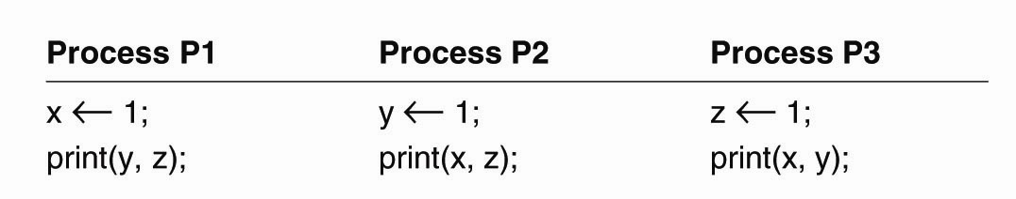
- No, 001110 is not a legal output for this due to the fact of sequential ordering and the last two printed digits being 10:
  - X 1;
  - Print(y, z);
  - In this order set by every process, x, y, or z is initially set to 1.
  - Following this, a print statement produces the result of the other two.
  - No matter what order chosen of these three processes, whether independent or together, there is no way to get the last 10.
  - This primarily lies in attempting to delay writing 1 to a variable past a print statement, which is not possible (in this scenario).

(20 points)3.Please briefly explain why the following example violates the sequential consistency?
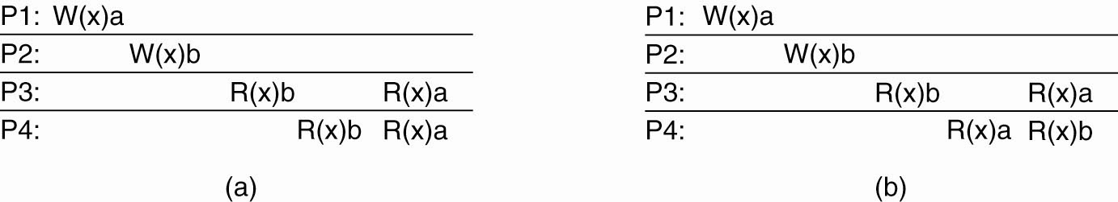
- Sequential consistency essentially lies in all processing obtaining the same output.
- In this scenario, we can see that P3 has a read statement of b before a.
- P4 however has a read statement of a before b.
- As such, since these two do not align, then this violates sequential consistency.

(20 points)4. The causal consistency model represents a weakening of sequential consistency. Please use one example to illustrate this. That is, please illustrate a sequence that is allowed with a causal consistency, but not with sequential consistency. Then briefly explain.
- I will be using an image from the slides to explain.
- 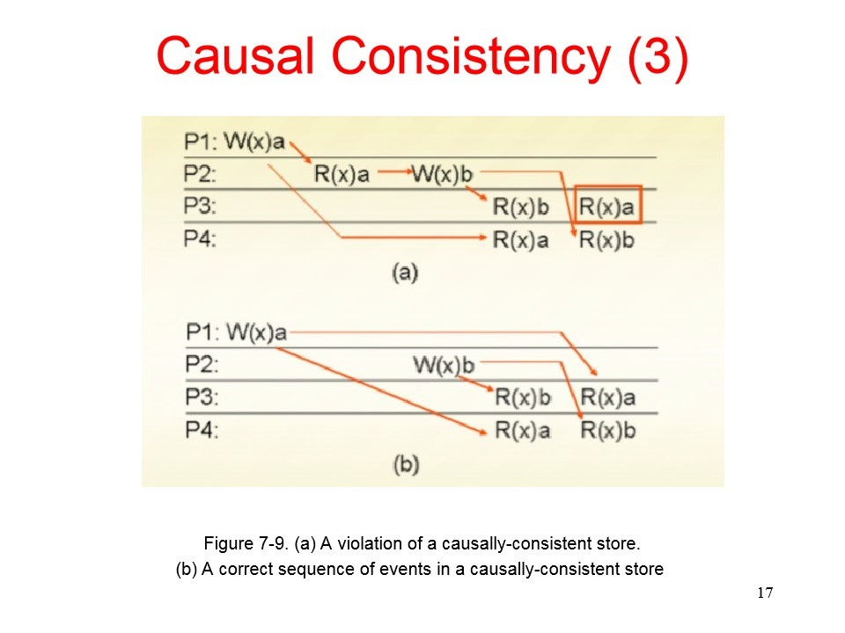
- In part b), we can see that P1 and P2 run a write function concurrently. As such, this can be interpreted differently if the read functions are called, in which they are in both P3 and P4. Both have different orders of the read functions. This is fine in causal consistency as the write functions do not have a causal relationship (as shown in a)).
- This, however, does not bide well with sequential consistency, which requires both P3 and P4 to have the same output, or the same order of the read functions. As such, sequential consistency is stronger as it makes sure all processes have the same order of events, but causal consistency does not require this, making it weaker.

(25 points)5. What are the basic ideas of remote-write and local-write protocols to provide sequential consistency?
- Remote Write
  - There are a few backup data stores, and every data item only has 1 primary data store.
  - When a client wants to read the data item, there is no issue. The client must just contact its local data store and read the item.
  - When a client wants to write to the data item, it must go through a few steps. This starts with contact its local store with a write operation.
  - Following this, the local store then contacts the primary store for the data item using a write function.
  - The primary store accepts this and makes sure to update all other backups. This is done by sending a write function to all other backups from the primary store.
  - After a process is completed updating its local data store of the data item, it returns an ACK message back to the primary store.
  - After the primary store has an ACK from every backup data store, then a ACK is sent back to the client’s data store.
  - Finally, the client’s data store assures the client that the changes have been made.
- Local write
  - The set-up is essentially the same, a few backup data stores, and every data item only has 1 primary data store.
  - When a client wants to read the data item, there is no issue. The client must just contact its local data store and read the item.
  - When a client wants to write to the data item, it must go through a few steps. This starts with contact its local store with a write operation.
  - Following this, the local store then contacts the primary store for the data item using a write function. This then migrates the data item from the initial primary store to the backup store that requested a write for the data item. This now becomes the new primary store.
  - The primary store then sends a write function to all other backups from the primary store.
  - After a process is completed updating its local data store of the data item, it returns an ACK message back to the primary store.
  - After the primary store has an ACK from every backup data store, then primary store assures the client that the changes have been made.

How to Turn In:
Softcopy: Please use BlackBoard to turn in your homework solutions.

